* 1. **Screenshots**
  2. **Screen 1:** Domestic Address Search

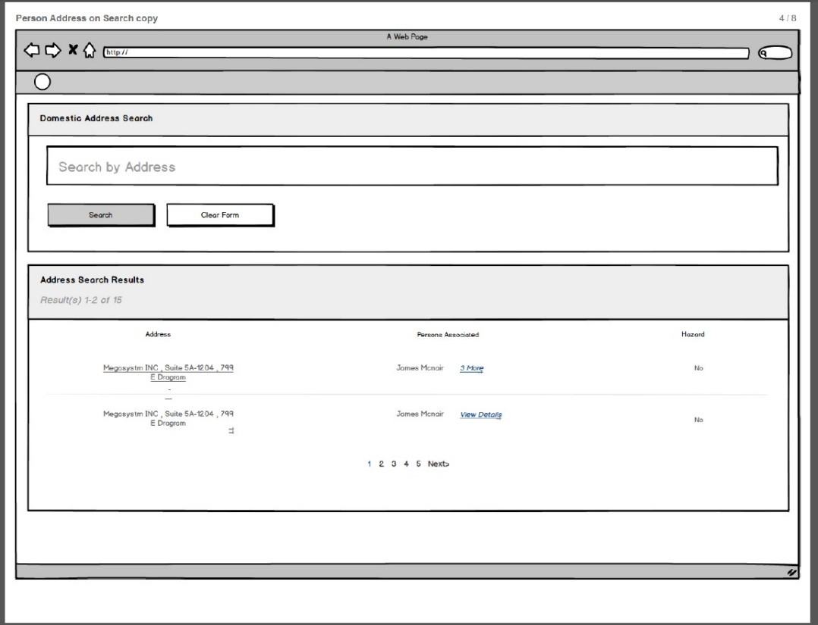

Note: There should be a CLOSE button, once the Address is searched, so that the user can go back to the calling use case.

* + 1. **Screen Fields**

| **Class.Attribute Name** | **Display Name** | **Type** | **Align** | **Size** | **Read**  **Only** | **Calculation** | **Edit Mask** | **To Be**  **UI Validation** |
| --- | --- | --- | --- | --- | --- | --- | --- | --- |
| N/A | Domestic Address Search | Section Header | L | N/A | T |  |  |  |
| N/A | Search By address | Text Box | L | 100 | T |  |  | Search by Address Eg:<address string> has to be displayed on the UI |
| N/A | Search Results | Section Header | L | N/A | T |  |  |  |
| N/A | Address | Display text | L | 100 | T |  |  | Concatenated address string. |
| N/A | Person Associated | Display Text | L | 100 | T |  |  | All the persons associated to the searched address should be displayed |
| ADDRESS.EnvHazardFlag | Hazard | Display text | L | 100 | T |  |  | If the EnvHazard flag is true for the address, then this has to be displayed |
|  | Actions | Display Text | L | 100 | T |  |  |  |

* + 1. **Action Buttons/Hyperlinks**

| **Label** | **Type** | **On Click Action/Navigation** |
| --- | --- | --- |
| Search | Button | The system will search for addresses based on the entered address. |
| Clear Form | Button | All cached screen data will be erased. All fields will be re-initialized. |
| Select | Hyperlink | Returns the selected address to the calling use case. |
| View details | Hyperlink | Launches the Persons Associated Screen (screen 2) |
| Address | Hyperlink | Launches Address screen |

* 1. **screen 2: Persons Associated**

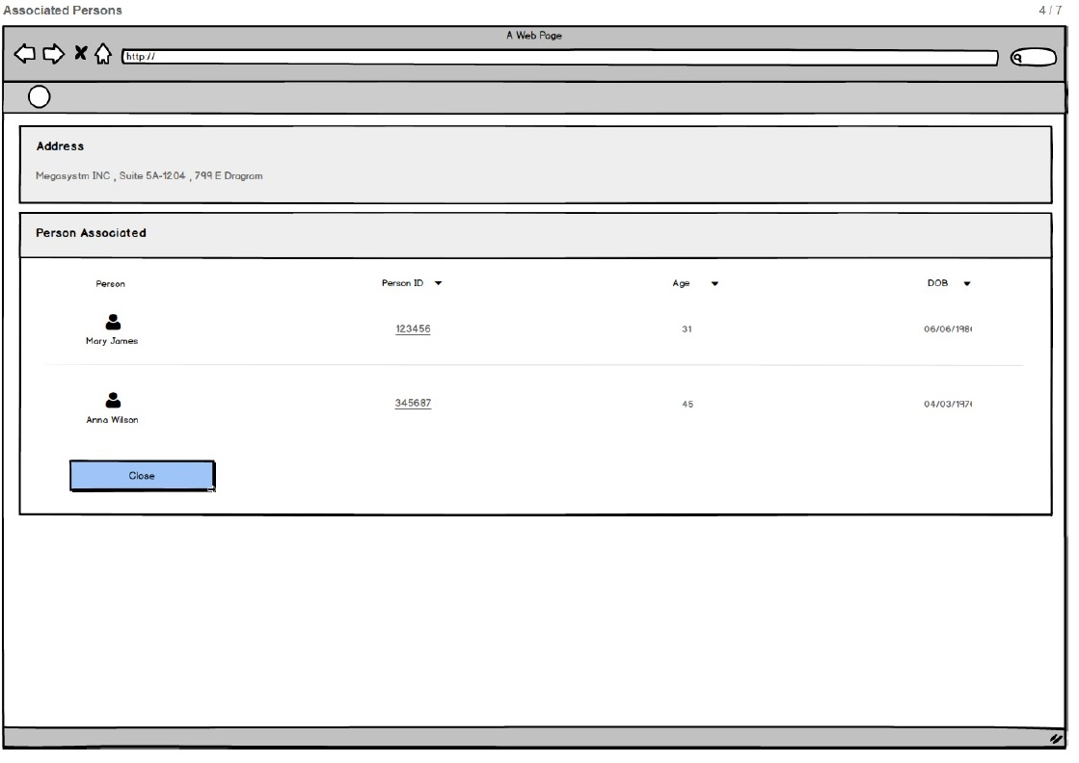

* + 1. **Screen Fields**

| **Class.Attribute Name** | **Display Name** | **Type** | **Align** | **Size** | **Read**  **Only** | **Calculation** | **Edit Mask** | **To Be**  **UI Validation** |
| --- | --- | --- | --- | --- | --- | --- | --- | --- |
| N/A | Address | Display Text | L |  | T | Use Standard Address format |  | Pulled from the address associated |
| N/A | Person Associated | Section Header | L | N/A | T |  |  |  |
| PERSON.PersonID | Person ID | Display text | L | 22 | T |  |  | Pulled from the person record. |
| PERSON.lastName + PERSON.suffix +  PERSON.firstName +  PERSON.middleName | Person Name | Display Text | L | 100 | T |  | Last Name Suffix, First Name Middle Name | Pulled from the person record. |
| PERSON.BirthDate | Age | Display text | L | 3 | T |  | Standard Age List format | Pulled from the person record |
| PERSON.BirthDate | DOB | Display text | L | 10 | T |  |  | Pulled from the person record |

**1.2.2 Action Buttons/Hyperlinks**

| **Label** | **Type** | **On Click Action/Navigation** |
| --- | --- | --- |
| Person ID | Hyperlink | Navigates to person over view screen |
| Close | Button | User returned to calling page |

**2. Story**

As a worker, I want find address information so that I can associate address details to an USFN entity (i.e. Agency, Person, Provider).

**3.1 Points to Note**

N/A

**3.2 Demo Steps**

1. Login to the USFN application with the following credentials
2. Username: samweaver
3. Any Password works.
4. The My Organizer is displayed after successful login.
5. Click 'View All' hyperlink.
6. In 'Non CPS Workload' page, click 'Intake ID' any non-cps intake (Status: Pending).
7. 'Basic Information' page should be displayed with Intake's details pre-filled.
8. Click 'Participant' side menu item, so that 'Participant ‘page will be displayed
9. In the page, (participants should be searched and linked) click 'Name' hyperlink
10. Person Details page should be displayed, with Person's details prefilled in header
11. Click 'Person Profile' button, so that 'Basic Information' page will be displayed with person details pre-filled
12. Click 'Address' side menu item,
13. Click on ‘Add Address’ button

Search Address screen is launched (Screen 1).

1. Enter the Address in the text box and click on Search.

Search Includes:

Step 1:

Search in the smartystreet to verify if the address is valid or not.

1. If the Address is NOT valid, then the search result is not displayed.

An error message “This is not a valid address is displayed”

1. If the Address is Valid, then follow Step 2.

Step 2:

Check if the address is already available in the database.

1. If the address already exists in the database, then display in the search results.
2. If the address does not exist in the DB, then insert the address in the database for the related Person ID.
3. Display the address in the search results.
4. Click on the Select hyperlink for the corresponding address.

Address will be selected and displayed on the Person Address Screen.

**4. Acceptance criteria**

**4.1 Screen 1 Acceptance criteria**

|  |  |  |  |
| --- | --- | --- | --- |
| # | Requirement | Execution Event | Status |
|  | In Search textbox, user has to search for the exact address: If the address is not valid, “This is not a valid address is displayed” | Click on “search button” |  |
| 1. 2 | After successful address is found, then user can link the selected person to the address by clicking ‘Select’ hyperlink’. | Clicking on ‘select hyperlink’ |  |
|  | After navigating back from person associated screen the system should retain the previous search results | Clicking on close button. |  |
|  | If the address is valid; but not available in the database, then the new address should be added into the DB. | On clicking Search |  |
|  | If there is one Person Associated to the Address, then Person Associated should be display the ‘View Details’ hyper link next to the Person’s name. | On Search Result displayed |  |
|  | If there are more than one Person Associated to the Address, then Person Associated should be display the ‘n more’ hyper link next to the Person’s name, where n depicts the actual number of persons mapped to the address. | On Search Result displayed |  |

6. Reference Values

| **No.** | **Status (Keep/Add/Modify/Delete)** | **To Be Class Attribute** | **Domain Code** | **Short Desc** | **Ref Data Code** |
| --- | --- | --- | --- | --- | --- |
| 1 | Keep | ADDRESS.PreDirectionalCode &  ADDRESS.PostDirectionalCode | Direction | E | E |
| N | N |
| NE | NE |
| NW | NW |
| S | S |
| SE | SE |
| SW | SW |
| W | W |
| PO Box | POBOX |
| 2 | Keep | ADDRESS.StreetSuffixCode | StreetSuffix | Alley | ALY |
| Annex | ANX |
| Arcade | ARC |
| Avenue | AVE |
| Bayou | BYU |
| Beach | BCH |
| Bend | BND |
| Bluff | BLF |
| Bluffs | BLFS |
| Bottom | BTM |
| Boulevard | BLVD |
| Branch | BR |
| Bridge | BRG |
| Brook | BRK |
| Brooks | BRKS |
| Burg | BG |
| Burgs | BGS |
| Bypass | BYP |
| Camp | CP |
| Canyon | CYN |
| Cape | CPE |
| Causeway | CSWY |
| Center | CTR |
| Centers | CTRS |
| Circle | CIR |
| Circles | CIRS |
| Cliff | CLF |
| Cliffs | CLFS |
| Gateway | GTWY |
| Glen | GLN |
| Glens | GLNS |
| Green | GRN |
| Greens | GRNS |
| Grove | GRV |
| Groves | GRVS |
| Harbor | HBR |
| Harbors | HBRS |
| Haven | HVN |
| Heights | HTS |
| Highway | HWY |
| Hill | HL |
| Hills | HLS |
| Hollow | HOLW |
| Inlet | INLT |
| Island | IS |
| Islands | ISS |
| Isle | ISLE |
| Junction | JCT |
| Club | CLB |
| Common | CMN |
| Commons | CMNS |
| Corner | COR |
| Corners | CORS |
| Course | CRSE |
| Court | CT |
| Creek | CRK |
| Crescent | CRES |
| Crest | CRST |
| Courts | CTS |
| Cove | CV |
| Coves | CVS |
| Crossing | XING |
| Crossroad | XRD |
| Curve | CURV |
| Dale | DL |
| Dam | DM |
| Drive | DR |
| Drives | DRS |
| Divide | DV |
| Estate | EST |
| Estates | ESTS |
| Expressway | EXPY |
| Extension | EXT |
| Extensions | EXTS |
| Fall | FALL |
| Falls | FLS |
| Ferry | FRY |
| Field | FLD |
| Junctions | JCTS |
| Knoll | KNL |
| Knolls | KNLS |
| Key | KY |
| Keys | KYS |
| Lake | LK |
| Lakes | LKS |
| Land | LAND |
| Landing | LNDG |
| Lane | LN |
| Light | LGT |
| Lights | LGTS |
| Loaf | LF |
| Lock | LCK |
| Locks | LCKS |
| Lodge | LDG |
| Loop | LOOP |
| Mall | MALL |
| Manor | MNR |
| Manors | MNRS |
| Meadow | MDW |
| Meadows | MDWS |
| Mews | MEWS |
| Mill | ML |
| Mills | MLS |
| Mission | MSN |
| Mount | MT |
| Mountain | MTN |
| Motorway | MTWY |
| Neck | NCK |
| Orchard | ORCH |
| Oval | OVAL |
| Overpass | OPAS |
| Park | PARK |
| Parkway | PKWY |
| Pass | PASS |
| Passage | PSGE |
| Path | PATH |
| Pike | PIKE |
| Place | PL |
| Plain | PLN |
| Plains | PLNS |
| Plaza | PLZ |
| Pine | PNE |
| Pines | PNES |
| Point | PT |
| Points | PTS |
| Port | PRT |
| Ports | PRTS |
| Prairie | PR |
| Radial | RADL |
| Ramp | RAMP |
| Ranch | RNCH |
| Rapid | RPD |
| Rapids | RPDS |
| Rest | RST |
| Ridge | RDG |
| Ridges | RDGS |
| River | RIV |
| Road | RD |
| Roads | RDS |
| Route | RTE |
| Row | ROW |
| Rue | RUE |
| Run | RUN |
| Shoal | SHL |
| Shoals | SHLS |
| Shore | SHR |
| Shores | SHRS |
| Skyway | SKWY |
| Spring | SPG |
| Springs | SPGS |
| Spur | SPUR |
| Square | SQ |
| Flat | FLT |
| Flats | FLTS |
| Ford | FRD |
| Fords | FRDS |
| Forest | FRST |
| Forge | FRG |
| Forges | FRGS |
| Fork | FRK |
| Forks | FRKS |
| Fort | FT |
| Freeway | FWY |
| Garden | GDN |
| Gardens | GDNS |
| Fields | FLDS |
| Squares | SQS |
| Station | STA |
| Stravenue | STRA |
| Stream | STRM |
| Street | ST |
| Streets | STS |
| Summit | SMT |
| Terrace | TER |
| Throughway | TRWY |
| Trace | TRCE |
| Track | TRAK |
| Trafficway | TRFY |
| Trail | TRL |
| Trailer | TRAILER |
| Tunnel | TUNL |
| Turnpike | TPKE |
| Underpass | UPAS |
| Union | UN |
| Unions | UNS |
| Valley | VLY |
| Valleys | VLYS |
| Viaduct | VIA |
| View | VW |
| Views | VWS |
| Ville | VL |
| Village | VLG |
| Villages | VLGS |
| Vista | VIS |
| Walk | WALK |
| Wall | WALL |
| Way | WAY |
| Ways | WAYS |
| Well | WL |
| Wells | WLS |
| 3 | Keep | ADDRESS.UnitNameCode | UnitName | Apartment | APT |
| Basement | BSMT |
| Box | BOX |
| Building | BLDG |
| Department | DEPT |
| Floor | FL |
| Front | FRNT |
| Hangar | HNGR |
| Lobby | LBBY |
| Lot | LOT |
| Lower | LOWR |
| Office | OFC |
| Penthouse | PH |
| Pier | PIER |
| PO Box | POBOX |
| Rear | REAR |
| Room | RM |
| Side | SIDE |
| Slip | SLIP |
| Space | SPC |
| Suite | STE |
| Stop | STOP |
| Trailer | TRLR |
| Unit | UNIT |
| Upper | UPPR |
| 4 | Keep | ADDRESS.StateCode | State | Alabama | AL |
| Alaska | AK |
| American Samoa | AS |
| Arizona | AZ |
| Arkansas | AR |
| Atlantic Theater of Operations | AA |
| California | CA |
| Colorado | CO |
| Connecticut | CT |
| Kansas | KS |
| Kentucky | KY |
| Louisiana | LA |
| Maine | ME |
| Marshall Islands | MH |
| Maryland | MD |
| Massachusetts | MA |
| Michigan | MI |
| Minnesota | MN |
| Mississippi | MS |
| Missouri | MO |
| Montana | MT |
| Nebraska | NE |
| Nevada | NV |
| New Hampshire | NH |
| New Jersey | NJ |
| New Mexico | NM |
| New York | NY |
| North Carolina | NC |
| North Dakota | ND |
| Northern Mariana Islands | MP |
| Ohio | OH |
| Oklahoma | OK |
| Oregon | OR |
| Palua | PW |
| Pennsylvania | PA |
| Puerto Rico | PR |
| Pacific Theater of Operations | AP |
| Rhode Island | RI |
| South Carolina | SC |
| South Dakota | SD |
| Tennessee | TN |
| Texas | TX |
| Utah | UT |
| Vermont | VT |
| Virgin Islands | VI |
| Virginia | VA |
| Washington | WA |
| West Virginia | WV |
| Wisconsin | WI |
| Wyoming | WY |
| 5 | Add | Address.TribalReservationCode | TribalReservation | These values have not been provided by the State yet. |  |
| 6 | Modify | County |  | **Non-Spec. County** | **NONSPECCOUNTY** |
| **Alcona** | **ALCONA** |
| **Alger** | **ALGER** |
| **Allegan** | **ALLEGAN** |
| **Alpena** | **ALPENA** |
| **Antrim** | **ANTRIM** |
| **Arenac** | **ARENAC** |
| **Baraga** | **BARAGA** |
| **Barry** | **BARRY** |
| **Bay** | **BAY** |
| **Benzie** | **BENZIE** |
| **Berrien** | **BERRIEN** |
| **Branch** | **BRANCH** |
| **Calhoun** | **CALHOUN** |
| **Cass** | **CASS** |
| **Charlevoix** | **CHARLEVOIX** |
| **Cheboygan** | **CHEBOYGAN** |
| **Chippewa** | **CHIPPEWA** |
| **Clare** | **CLARE** |
| **Clinton** | **CLINTON** |
| **Crawford** | **CRAWFORD** |
| **Delta** | **DELTA** |
| **Dickinson** | **DICKINSON** |
| **Eaton** | **EATON** |
| **Emmet** | **EMMET** |
| **Genesee** | **GENESEE** |
| **Gladwin** | **GLADWIN** |
| **Gogebic** | **GOGEBIC** |
| **Grand Traverse** | **GRANDTRAVERSE** |
| **Gratiot** | **GRATIOT** |
| **Hillsdale** | **HILLSDALE** |
| **Houghton** | **HOUGHTON** |
| **Huron** | **HURON** |
| **Ingham** | **INGHAM** |
| **Ionia** | **IONIA** |
| **Iosco** | **IOSCO** |
| **Iron** | **IRON** |
| **Isabella** | **ISABELLA** |
| **Jackson** | **JACKSON** |
| **Kalamazoo** | **KALAMAZOO** |
| **Kalkaska** | **KALKASKA** |
| **Kent** | **KENT** |
| **Keweenaw** | **KEWEENAW** |
| **Lake** | **LAKE** |
| **Lapeer** | **LAPEER** |
| **Leelanau** | **LEELANAU** |
| **Lenawee** | **LENAWEE** |
| **Livingston** | **LIVINGSTON** |
| **Luce** | **LUCE** |
| **Mackinac** | **MACKINAC** |
| **Macomb** | **MACOMB** |
| **Manistee** | **MANISTEE** |
| **Marquette** | **MARQUETTE** |
| **Mason** | **MASON** |
| **Mecosta** | **MECOSTA** |
| **Menominee** | **MENOMINEE** |
| **Midland** | **MIDLAND** |
| **Missaukee** | **MISSAUKEE** |
| **Monroe** | **MONROE** |
| **Montcalm** | **MONTCALM** |
| **Montmorency** | **MONTMORENCY** |
| **Muskegon** | **MUSKEGON** |
| **Newaygo** | **NEWAYGO** |
| **Oakland** | **OAKLAND** |
| **Oceana** | **OCEANA** |
| **Ogemaw** | **OGEMAW** |
| **Ontonagon** | **ONTONAGON** |
| **Osceola** | **OSCEOLA** |
| **Oscoda** | **OSCODA** |
| **Otsego** | **OTSEGO** |
| **Ottawa** | **OTTAWA** |
| **Presque Isle** | **PRESQUEISLE** |
| **Roscommon** | **ROSCOMMON** |
| **Saginaw** | **SAGINAW** |
| **St Clair** | **STCLAIR** |
| **St Joseph** | **STJOSEPH** |
| **Sanilac** | **SANILAC** |
| **Schoolcraft** | **SCHOOLCRAFT** |
| **Shiawassee** | **SHIAWASSEE** |
| **Tuscola** | **TUSCOLA** |
| **Van Buren** | **VANBUREN** |
| **Washtenaw** | **WASHTENAW** |
| **Wayne** | **WAYNE** |
| **Wexford** | **WEXFORD** |

## 